**COMMON CRISES IN PAEDIATRIC ANAESTHESIA**

**LOCAL ANAESTHETIC TOXICITY**

1. **RECOGNITION**

**Signs of severe toxicity:**

* Sudden alteration in mental status, severe agitation or loss of consciousness, with or without tonic-clonic convulsions
* Cardiovascular collapse: sinus bradycardia, conduction blocks, asystole and ventricular tachyarrhythmias may all occur
* Local anaesthetic (LA) toxicity may occur sometime after an initial injection

1. **IMMEDIATE MANAGEMENT**

* Stop injecting LA
* Call for help
* Maintain and/or secure airway
* Give 100% oxygen and ensure adequate lung ventilation (hyperventilation may help by increasing plasma pH in the presence of metabolic acidosis)
* Confirm or establish intravenous access
* Control seizures: give a benzodiazepine (1st choice) or thiopental in small incremental doses. AVOID Propofol in presence of haemodynamic instability
* Assess cardiovascular status throughout
* Consider drawing blood for analysis, but do not delay definitive treatment

**TREATMENT**

In the presence of Circulatory Arrest,

* Start CPR. Manage arrhythmias using ACLS protocol, (arrhythmias may be very refractory to treatment)
* For ventricular arrhythmias, amiodarone is preferred; avoid tAVOID vasopressin, beta blockers, Ca channel blockers, lignocaine or procainamide
* Consider the use of cardiopulmonary bypass if available

**Lipofundin N 20%**

Give an initial intravenous bolus injection of Lipofundin 20% 1.5ml/kg over 1 min AND start an infusion at 15 ml/kg/hour.

After 5 minutes, if cardiovascular stability has not been restored:

Consider a maximum of two repeat boluses (1.5ml/kg)

A maximum of threeboluses can be given (including the initial bolus) Leave 5 minutes between each bolus.

* Doublethe rate to 30 ml/kg/h and continue infusion until stable and adequate circulation restored or maximum dose of 12 ml/kg of lipid emulsiongiven
* Continue CPR throughout treatment with lipid emulsion
* Recovery from LA-induced cardiac arrest may take >1 h
* Propofol is not a suitable substitute for lipid emulsion
* Lignocaine should not be used as an antiarrhythmic therapy

1. **FOLLOW-UP**

Arrange safe transfer to a clinical area with appropriate equipment and suitable staff until sustained recovery is achieved.

Exclude pancreatitis by regular clinical review, including daily amylase or lipase assays for two days.

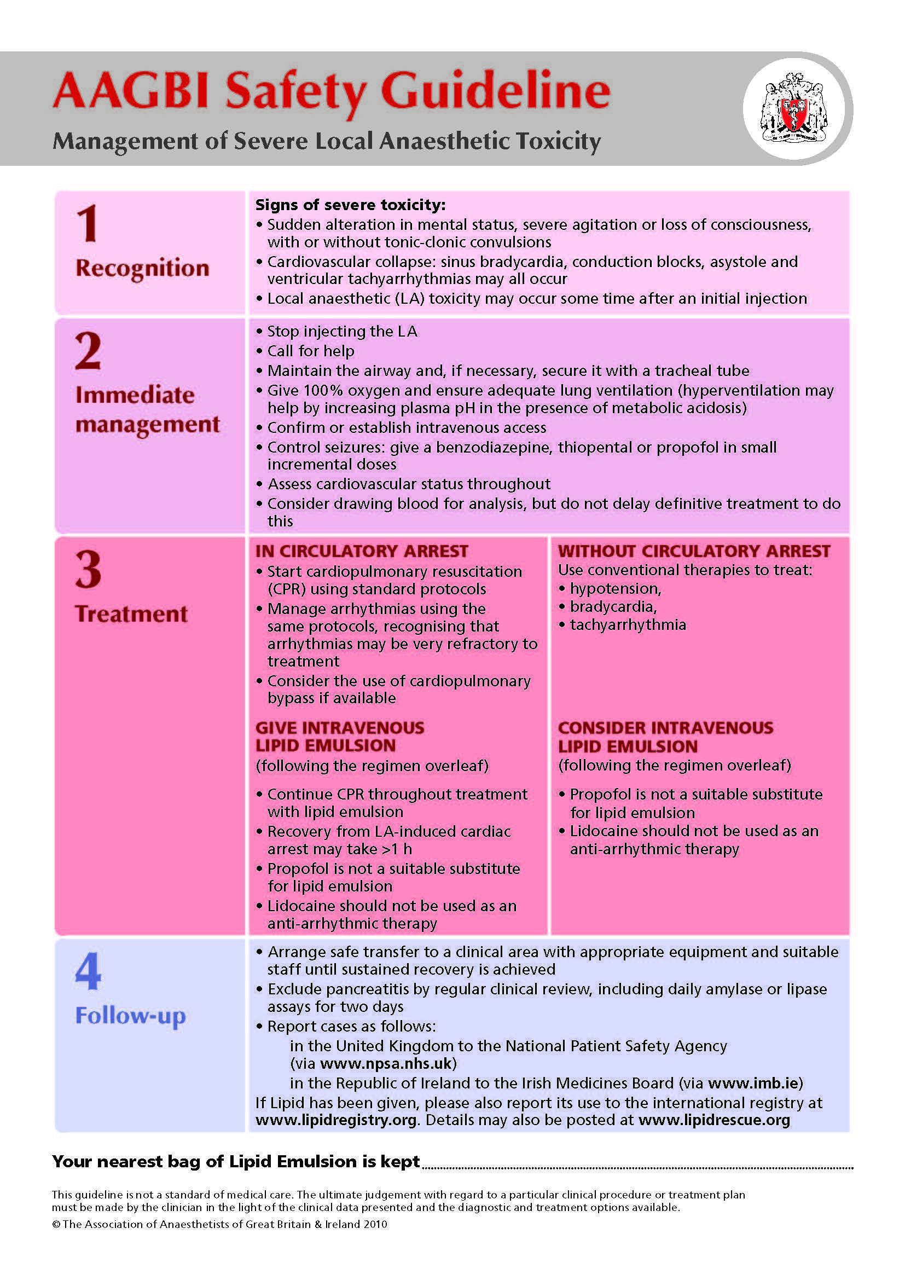

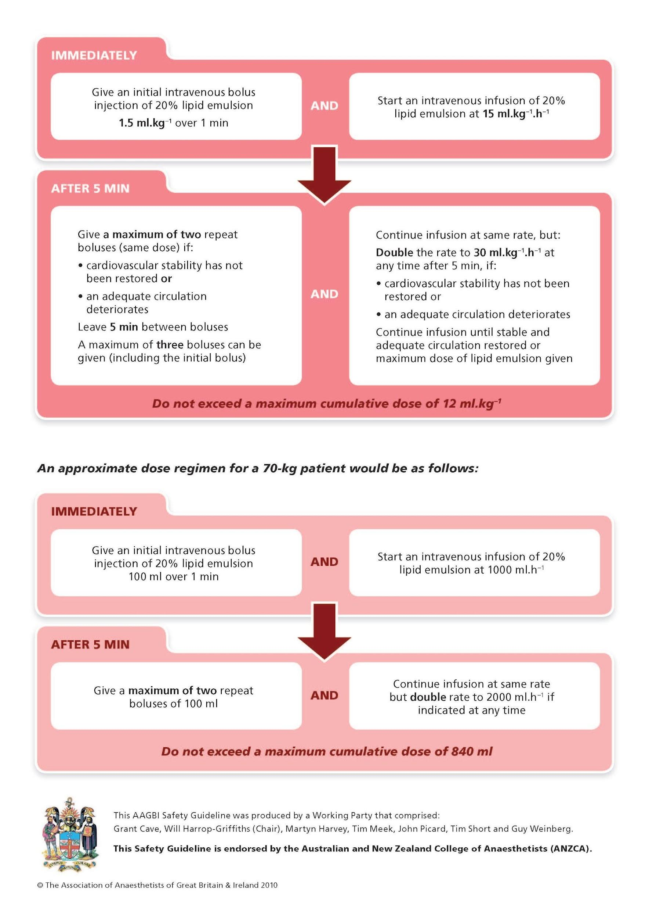

*References:*

1. *AAGBI Safety Guideline: Management of Severe Local Anaesthetic Toxicity 2010.*
2. *Neal et al. ASRA Practice Advisory on Local Anesthetic Systemic Toxicity Regional Anesthesia and Pain Medicine & Volume 35, Number 2, March-April 2010*